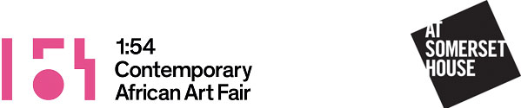

For immediate release

1:54 Contemporary African Art Fair
Somerset House, London, 6–9 October 2016

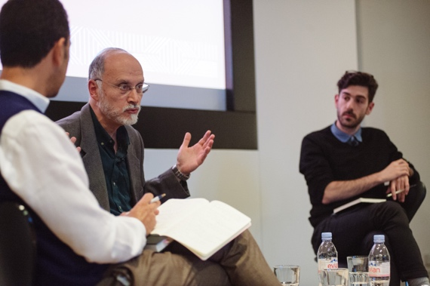
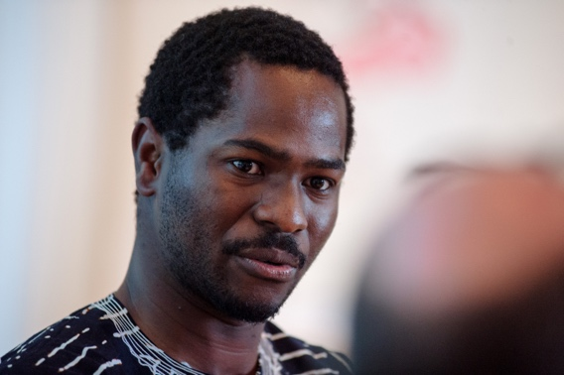
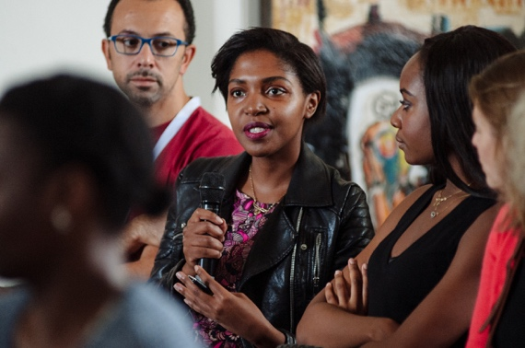
1:54 announces FORUM programme, curated by Koyo Kouoh, for the 2016 London edition at Somerset House

FORUM London 2015. From left to right: Richard Mudariki; Omar Berrada, Professor Gilbert Achcar and Dr Andrew Arsan; audience Q&A. Images courtesy of 1:54 © Benjamin Hoffman.

- Sixth edition of FORUM will explore the crossovers between contemporary art, design, fashion, architecture and urbanism
- Lectures by Ekow Eshun and Aaron Kohn
- Artist talks with Serge Attukwei Clottey, Michele Mathison and Joël Andrianomearisoa
- Discussions on collaborative design projects include:
‘Antidisciplinarity in architecture’, ‘Rediscovering the ordinary’ and ‘Malick Sidibé: The People's Photographer, A Malian Legend’

1:54 Contemporary African Art Fair has announced details for FORUM – the fair’s extensive talks and events programme curated by Koyo Kouoh (Founding artistic director of Raw Material Company, Dakar) for the 2016 London edition of the fair, taking place at Somerset House, 6 – 9 October 2016.

1:54 will showcase 40 leading specialist galleries from 18 countries and more than 130 African and African diasporan artists. Highlights of the special projects programme include the first major UK solo exhibition of late Malian photographer Malick Sidibé, new sculptures by Zak Ové in the Edmond J. Safra Fountain Court and a presentation of The Arab Spring Notebook by artist Ibrahim El Salahi.

FORUM will explore the generative slippages between contemporary art, photography, fashion, object and furniture design, architecture and urbanism. Through a variety of discursive forms including lectures, discussions and screenings, the programme will demonstrate the influence and confluence of African perspectives in contemporary art and design with that of diverse aesthetics and material practices around the world.

The programme aims to address three key questions: how are material forms being radically reconfigured or redeployed by African and African diasporan practitioners; what kinds of narratives are emerging out of contemporary practices working between art and design; and how are interdisciplinary collaborations producing new modes of engagement with material culture, popular culture, history, politics and ethics?

As part of a wide appraisal of interdisciplinary material practice, FORUM will explore the proliferation of contemporary channels and modes of distribution – from the Internet to the various self-organising strategies afforded by the digital – to question how resources themselves are being repurposed, and how artists and designers are responding to these shifts within ‘material’ classifications.

The keynote speaker for 2016 is Ekow Eshun, a writer and broadcaster, and former artistic director of the Institute of Contemporary Arts, London. Other speakers include Azu Nwagbogu (Founding Director, African Artists' Foundation and LagosPhoto Festival) and
Aaron Kohn (Executive Director, Museum of African Design); curators Amelie Klein (Vitra Design Museum), Kerryn Greenberg (Tate Modern) and André Magnin (MAGNIN-A); architects Rashid Ali (RA Projects), Glenn DeRoche (Adjaye Associates) and Kunlé Adeyemi (NLÉ), and Mark Rappolt (Editor in Chief, ArtReview). Participating artists and designers include Serge Attukwei Clottey, Michele Mathison, Joël Andrianomearisoa, Phoebe Boswell, Ifeanyi Oganwu, Karo Akpokiere, Hassan Hajjaj and Driss Ouadahi.

Koyo Kouoh says: “In an African postcolonial perspective, challenging the paradigms of creative disciplines dovetails with a critical examination of legacy and identity. Experimentation and play, as well as subversion, are crucial to exploding cultural and historical platitudes about Africa.”

FORUM Film is a related daily film programme screening artist works and documentaries. The full schedule will be announced at the end of September. No booking is required.

FORUM and FORUM Film will take place in the Screening Room in the South Wing. Access to FORUM is free with admission to 1:54. Please note that as tickets are limited, free seat reservations must be made by Eventbrite here.

FORUM 2016

Thursday 6 October

12.00 – 13.00 FORUM Film

13.00 – 13.15 Opening remarks: Material propositions
Koyo Kouoh (Curator of FORUM)

13.30 – 14.30 Keynote
Ekow Eshun (writer and broadcaster). Followed by audience Q&A.

15.00 – 16.00 Artist talk
Serge Attukwei Clottey in conversation with Erin Jenoa Gilbert (curator, critic and cultural producer).

16.30 – 17.30 Artist talk: Rediscovering the ordinary
Michele Mathison (artist) in conversation with Liese Van Der Watt (critic). Referencing South African writer Njabulo Ndebele’s injunction to rediscover the power of the ordinary, this conversation will focus on Mathison’s sculptural practice which shows us how the ordinary is intimately connected to and revealing of wider political circuits of labour and cultivation, of power, globalisation and migrancy.
Friday 7 October

12.00 – 13.00 FORUM Film

13.30 – 14.30 Lecture: African design: locating ‘It' and its constituents
Aaron Kohn (Executive Director, Museum of African Design, Johannesburg) with comments from Mark Rappolt (Editor-in-Chief, ArtReview).

15.00 – 16.00 Artist talk: Without beginning or end
Joël Andrianomearisoa will discuss his practice and relationship to material with Huguette Malamba (Programme Specialist & Director of Diversity and Cultural Development, l’Organisation internationale de la Francophonie).
This conversation will be in French with English interpretation

16.30 – 17.30 Discussion: Waveforms
Princess Alia Al-Senussi (academic and patron) in conversation with Phoebe Boswell (artist) and Ifeanyi Oganwu (architect, designer and Director at Expand Design Ltd, London). This discussion will focus on Boswell and Oganwu’s collaborative project for the 1:54 Lounge and bookshop, and more broadly, their approach to interdisciplinary practice.

Saturday 8 October

12.00 – 13.00 FORUM Film

13.30 – 14.45 Discussion: Material cultures
Chaired by Azu Nwagbogu (Founding Director, African Artists' Foundation, Lagos and LagosPhoto Festival), with Amelie Klein (Curator, Vitra Design Museum, Weil am Rhein) and artists Karo Akpokiere and Hassan Hajjaj.

15.15 – 16.45 Discussion: ‘Antidisciplinarity’ in architecture
Aaron Kohn (Executive Director, Museum of African Design, Johannesburg) in conversation with Kunlé Adeyemi (Founding Director, NLÉ, Amsterdam), Rashid Ali (Founding Director, RA Projects, London) and artist Driss Ouadahi. This discussion examines some of the sociopolitical, cultural, and urban conditions that underpin design and collaborative practice. Architecture in Africa is changing the way we look at the continent, and architects are more often than ever being asked to solve problems beyond their domain.
Part of this conversation will be in French with English interpretation

17.15 – 18.15 Discussion: Africa in practice: an architectural dialogue
Aaron Kohn (Executive Director, Museum of African Design, Johannesburg) in conversation with Glenn DeRoche (Project Architect, Adjaye Associates, London). Deroche has worked on projects in North America, Europe, and Africa. Based in London, he now oversees projects across Africa, and has worked on opening an office in Accra. Global firms like Adjaye Associates are (re)turning to Africa in different capacities which means a new practice for many.

Sunday 8 October

12.00 – 13.00 FORUM Film

13.30 – 14.30 Discussion: Malick Sidibé: The People's Photographer, a Malian Legend
To coincide with Malick Sidibé's first exhibition in the United Kingdom, Kerryn Greenberg (Curator, International Art at Tate Modern), André Magnin (Director of MAGNIN-A and author of the first monograph of Malick Sidibé) and Mark Sealy (Director of Autograph ABP) will discuss the artist's work and legacy.
Part of this conversation will be in French with English interpretation.

15.00 – 16.30 Book launch & screening: Nana Oforiatta Ayim: Agbako: Untold
The launch of ANO’s Limited Edition Books on Arts & Culture. A film and book on new museum and architectural models for a Ghanaian, and for wider African contexts. This edition is designed by young architect and artist Latifah Idriss, and supported by Gallery 1957.

Press contact

Lisa Hill at SUTTON

lisa@suttonpr.com | +44 (0)20 7183 3577

1:54 FORUM Sponsors

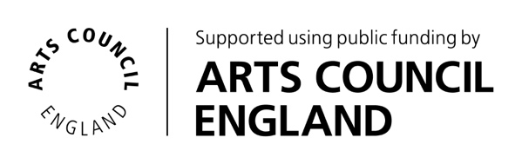

Notes to editors

About 1:54 Contemporary African Art Fair

With biannual editions in London and New York, 1:54 is the leading international art fair dedicated to contemporary art from Africa and its diaspora. Drawing reference to the fifty-four countries that constitute the African continent, 1:54 is a sustainable and dynamic platform that is engaged in contemporary dialogue and exchange.

Initiated by Touria El Glaoui in 2013, October 2016 will mark its fourth consecutive edition at Somerset House, having returned from its second New York edition in May 2016. 1:54 London 2016 will showcase 40 exhibitors, presenting over 130 African and African diasporan artists across the East, South and West Wings of Somerset House.

About 1:54 FORUM

As an independent section of 1:54 Contemporary African Art Fair, FORUM's discursive programme aims at exploring convergences across artistic and cultural production, critical thinking and ideas. FORUM is curated by Koyo Kouoh (RAW Material Company, Dakar).

About Floreat Group, 1:54 Main Sponsor

Floreat Group is a privately held, London-based independent financial group, with investments in public equities, private equity, real estate and debt. The group operates six UK businesses, and approach investments directly through their own funds and co-investment platforms.



Opening hours

Thursday 6 October 11 am – 7 pm
Friday 7 October 11 am – 7 pm
Saturday 8 October 11 am – 7 pm
Sunday 9 October 11 am – 6 pm

Social Media:

Website: 1-54.com

Twitter: @154artfair

Instagram: @154artfair

Facebook: 154ContemporaryAfricanArtFair

